

LABOR AND HUMAN RIGHTS POLICY

With effective from: 01/04/2023
Revision: 01

Apt #5, House # 3, Road # 23/B, Gulshan 1, Dhaka 1212.
+88 02 9853701
info@arrivalfashion.com
www.arrivalfashion.com

+91 332892516
✉ info@thejuteshop.com

+91 33 22892516
✉ info@thejuteshop.com

TABLE OF CONTENTS

Introduction 3
Scope 3
Policy Statement 4
Key Focus Area 4
SDGs Covered 6
Responsibility 6
Review Mechanism 7
Acknowledgement 7

Introduction

Arrival Fashion Ltd is dedicated to maintaining exemplary standards of labor and human rights throughout our operations. Our policy underscores our commitment to guaranteeing equitable, safe, and dignified working conditions for all employees, partners, and stakeholders. We strive to foster a workplace where every individual is respected, their fundamental rights safeguarded, and their dignity upheld.

Scope
This policy applies to all workers, employees, directors, officers, agents, contractors, and any third parties acting on behalf of Arrival Fashion Ltd. (AFL). It covers all business activities, including procurement, sales, marketing, and any interactions with government officials, customers, suppliers, and other stakeholders. The policy is applicable globally, regardless of local business practices or cultural norms. This policy applies to below mentioned locations:
Address: | - Apt No.5, House No. 3, Road No.23/B, Gulshan 1, Dhaka 1212.  - Arrival Fashion Ltd, Colomesshor, Board Bazar, Gazipur.  - Arrival Fashion Ltd, Plot 10, Block # Kha, Section 6, Road 1, Mirpur, Dhaka - 1216.  - Holding: 17, Vill: Mamarishpur, Post: Mallik Bari, P.s: Bhaluka, Dist: Mymensingh, Bangladesh.

Policy Statement
At Arrival Fashion, we are steadfast in our commitment to upholding the highest standards of labor and human rights across all facets of our operations. Our Labor and Human Rights Policy is designed to foster an environment where every individual is treated with dignity, respect, and fairness. This policy encompasses our dedication to equitable employment practices, the wellbeing and safety of our employees, open social dialogue, the elimination of child labor and forced labor, inclusion and equal opportunities, work life balance, and continuous professional development.

Key Focus Areas
Below are our commitments and targets towards environmental sustainability as compared to baseline year 2022.

- Fair Employment Standards

Commitment: Ensure fair, transparent, and merit-based hiring, promotion, and compensation practices free from discrimination or bias.

Target by 2030:

- Achieve a 20% increase in workforce diversity across all levels compared to 2022.
- Conduct annual audits of recruitment, promotion, and pay equity to ensure 100% compliance with non-discrimination policies.

- Employee Health and Safety Standards

Commitment: Provide a safe and healthy working environment with preventive measures, safety training, and monitoring.

Target by 2030:

- Ensure 100% of employees complete annual health and safety training.

- Interactive Social Engagement

Commitment: Respect employees’ rights to freely associate, bargain collectively, and engage in social dialogue.

Target by 2030:

- Ensure 25 % of employees covered by formally elected employee representatives or collective agreements.
- Achieve 90% employee participation in engagement programs.

- Labor Relations

Commitment: Foster positive labor relations through open communication, collaboration, and access to grievance mechanisms.

Target by 2030:

- Ensure 100% of employees have access to grievance mechanisms.
- Conduct annual satisfaction surveys covering 100% of employees.

- Child Labor Prevention

Commitment: Strictly prohibit employment of children under the legal minimum age across operations and supply chain.
Target by 2030:

- Conduct 100% supplier audits for child labor compliance.
- Maintain 100% compliance with legal minimum age requirements.

- Forced Labor Prevention

Commitment: Strictly prohibit all forms of forced or compulsory labor within operations and supply chain.

Target by 2030:

- Conduct 100% supplier audits for forced labor compliance.
- Achieve 100% compliance with forced labor policies.

- Inclusive Equity Practices

Commitment: Provide equal opportunities for all employees, eliminate discrimination, and promote diversity, equity, and inclusion.

Target by 2030:

- Increase representation of underrepresented groups in management by 2 % compared to 2022.
- Ensure 100% of employees complete diversity, equity, and inclusion (DEI) training.

- Balanced Work Life Integration

Commitment: Promote healthy work-life balance through flexible working hours, remote work options, and wellness programs.

Target by 2030:

- Provide flexible work options to 15 % of the workforce.
- Implement wellness programs covering 100% of employees.
- Conduct annual employee surveys to achieve at least 80% satisfaction with work-life balance.

- Working Conditions

Commitment: Ensure safe, healthy, and compliant working conditions for all employees.

Target by 2030:

- Achieve 100% compliance with health and safety standards.
- Conduct annual improvements in ergonomic and environmental conditions at 100% operational sites.
- Comprehensive Career Development Integrated Work-Life Management

Commitment: Invest in employees’ professional development, career growth, and continuous learning.

Target by 2030:

- Increase participation in career development and skill training programs by 30% compared to 2022.
- Ensure 100% of employees have an annual personal development plan.

- Ongoing Enhancement

Commitment: Foster a culture of continuous improvement in all operational and organizational aspects.

Target by 2030:

- Achieve at least 5% annual improvement in all key operational and HR KPIs.
- Conduct annual audits covering 100% of operational and HR processes.

- External Stakeholder Human Rights

Commitment: Uphold human rights throughout the supply chain and with external stakeholders.

Target by 2030:

- Conduct human rights due diligence for 100% of key suppliers annually.
- Ensure zero (0) human rights violations across operations and supply chain.
- Provide training on human rights for 100% of procurement and supplier management staff.

- Fair Compensation

Commitment: Ensure all employees receive a living wage meeting basic needs and a decent standard of living.

Target by 2030:

- Ensure 100% of employees earn a living wage.
- Conduct annual compensation reviews for 100% of employees.

SDGs Covered
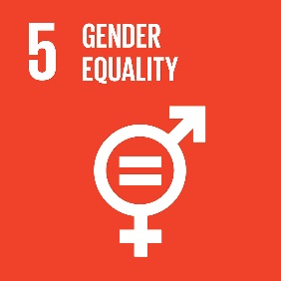
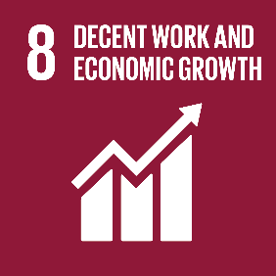
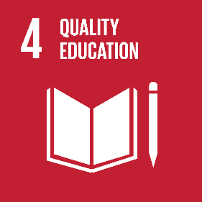
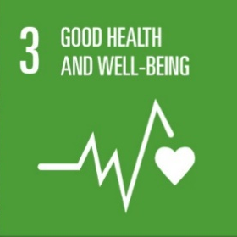
AFL is committed to achieve the following Sustainable Development Goals:
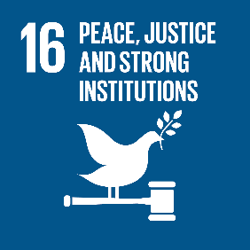
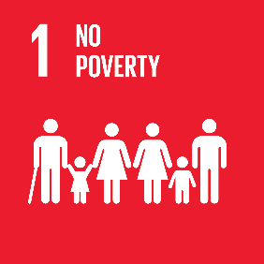
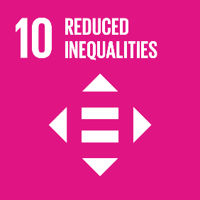

Responsibility
The implementation and oversight of this policy are the responsibilities of our Human Resources (HR) Manager, Mr. Mainuddin Sarker working closely with the Sustainability and Compliance teams. The HR department is charged with ensuring that all employees and stakeholders are informed about and comply with this policy. Regular assessments and updates will be carried out to evaluate progress and enact necessary enhancements. The Health and Safety Manager oversees compliance with legal and ethical standards, conducts health and safety training, supports diversity and inclusion efforts, and facilitates social dialogue and collective bargaining. We conduct regular reviews and external audits to uphold transparency and accountability.

Review Mechanism
To ensure the effectiveness of Arrival Fashion Ltd.’s Labor and Human Rights Policy, we have implemented a robust review mechanism that includes regular assessments, updates based on feedback, and stakeholder engagement, while staying aligned with industry standards and regulatory requirements:

The HR Manager conducts annual reviews of the policy to incorporate feedback and implement improvements.

The Health and Safety Manager provides regular progress reports on quantitative targets to be shared with stakeholders.

External audits conducted by the Safety Officer ensure transparency and accountability.
This structured approach ensures that our policies remain relevant, effective, and responsive to evolving needs and standards in labor and human rights practices.
Revision No. | Date | Description of Change
1.0 | 01/04/2023 | Initial release of Environmental Policy
2.0 | 08/09/2025 | Review and update of environmental targets and strengthening of the review mechanism
3.0 (Planned) | 08/09/2026 | Scheduled policy review in line with the defined review cycle

Acknowledgement
I, _________________________, acknowledge that I have read, understood, and agree to adhere to the company’s Labor & Human Rights Policy. I recognize the importance of my role in supporting the company's commitment to fair labor practices and am committed to actively participating in the implementation of this policy. I will strive to incorporate ethically responsible practices into my daily work activities, comply with all relevant labor regulations and company policies, and support the continuous improvement of our labor practices.

I understand that my commitment is essential to achieving the company's objectives and fostering a culture of a secure and respectful workplace. I am dedicated to contributing to our shared vision of fair and ethical business practices.

Employee Acknowledgement Name:
Employee Signature: Approved by:
Date: 08 SEPTEMBER 2025 General Manager of Operations
Next review date: 08 SEPTEMBER 2026

